# Os lab- 1-12-2022 CYS21033 SUHITHA K

1. FCFS

#include <stdio.h>

int main()

{

int pid[15];

int bt[15];

int n;

printf("Enter the number of processes: ");

scanf("%d",&n);

printf("Enter process id of all the processes: ");

for(int i=0;i<n;i++)

{

scanf("%d",&pid[i]);

}

printf("Enter burst time of all the processes: ");

for(int i=0;i<n;i++)

{

scanf("%d",&bt[i]);

}

int i, wt[n];

wt[0]=0;

//for calculating waiting time of each process

for(i=1; i<n; i++)

{

wt[i]= bt[i-1]+ wt[i-1];

}

float twt=0.0;

float tat= 0.0;

for(i=0; i<n; i++)

{

printf("Process:%d\n", pid[i]);

printf("burst time:%d\n", bt[i]);

printf("waiting time:%d\n", wt[i]);

//calculating and printing turnaround time of each process

printf("turnaround time:%d\n", bt[i]+wt[i]);

printf("\n");

//for calculating total waiting time

twt += wt[i];

//for calculating total turnaround time

tat += (wt[i]+bt[i]);

}

float att,awt;

//for calculating average waiting time

awt = twt/n;

//for calculating average turnaround time

att = tat/n;

printf("Avg. waiting time= %f\n",awt);

printf("Avg. turnaround time= %f",att);

}

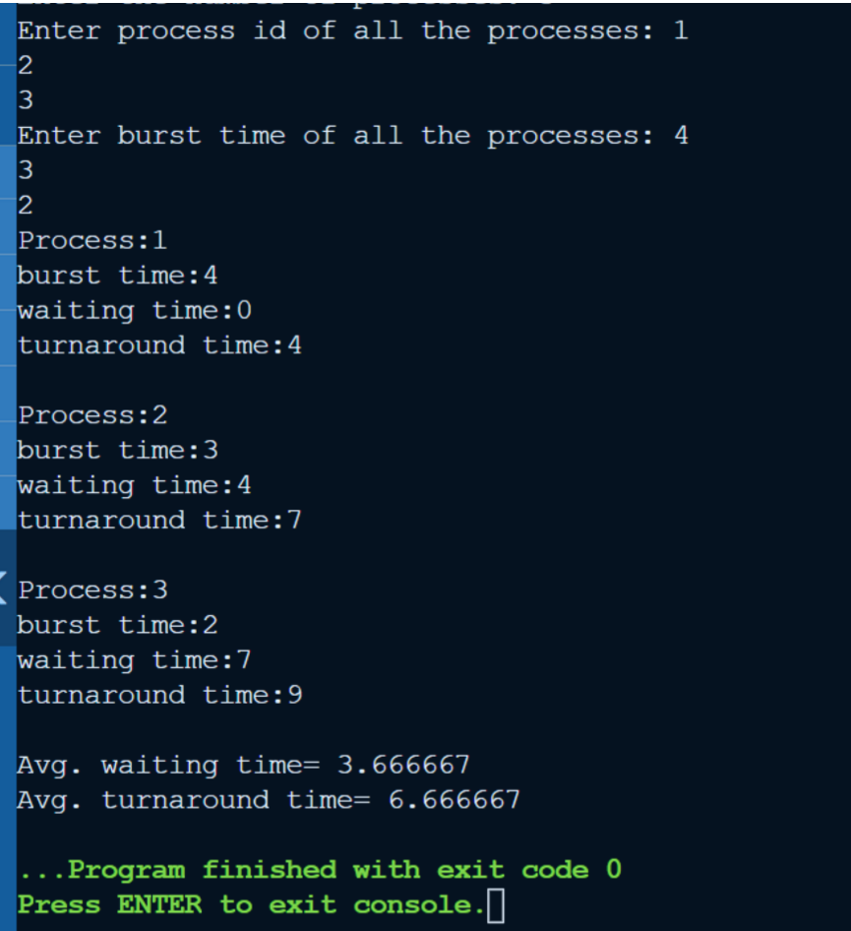

2. SJFS

#include<stdio.h>

int main()

{

int bt[20],p[20],wt[20],tat[20],i,j,n,total=0,pos,temp;

float avg_wt,avg_tat;

printf("Enter number of process:");

scanf("%d",&n);

printf("\nEnter Burst Time:n");

for(i=0;i<n;i++)

{

printf("p%d:\n",i+1);

scanf("%d",&bt[i]);

p[i]=i+1;

}

//sorting of burst times

for(i=0;i<n;i++)

{

pos=i;

for(j=i+1;j<n;j++)

{

if(bt[j]<bt[pos])

pos=j;

}

temp=bt[i];

bt[i]=bt[pos];

bt[pos]=temp;

temp=p[i];

p[i]=p[pos];

p[pos]=temp;

}

wt[0]=0;

for(i=1;i<n;i++)

{

wt[i]=0;

for(j=0;j<i;j++)

wt[i]+=bt[j];

total+=wt[i];

}

avg_wt=(float)total/n;

total=0;

for(i=0;i<n;i++)

{

tat[i]=bt[i]+wt[i];

total+=tat[i];

printf("\n\n\nProcess:p%d\nburst time:%d\nwait time:%d\nturnaround time:%d",p[i],bt[i],wt[i],tat[i]);

}

avg_tat=(float)total/n;

printf("\n\nAverage Waiting Time=%f",avg_wt);

printf("\nAverage Turnaround Time=%f\n",avg_tat);

}

